**ASSIGNMENT 1**

**HOME AUTOMATION**

**CODE:**

**int t=2;**

**int e=3;**

**int l=13;**

**void setup()**

**{**

**pinMode(t,OUTPUT);**

**pinMode(8,OUTPUT);**

**pinMode(7,OUTPUT);**

**pinMode(e,INPUT);**

**pinMode(l,OUTPUT);**

**Serial.begin(9600);**

**}**

**void loop()**

**{**

**digitalWrite(8,0);**

**int a=digitalRead(4);**

**Serial.println(a);**

**if(a==1)**

**{**

**digitalWrite(8,1);**

**Serial.println("Motion detected!!!");**

**}**

**delay(1000);**

**digitalWrite(t,0);**

**digitalWrite(t,1);**

**delayMicroseconds(10);**

**digitalWrite(t,0);**

**float dur=pulseIn(e,HIGH);**

**int dis=(dur*0.0343)/2;**

**analogWrite(l,map(dis,2,320,255,0));**

**double b=analogRead(A0);**

**double t=(((b/1024)*5)-0.5)*100;**

**Serial.print("temperature value: ");**

**Serial.println(t);**

**if(t>100)**

**digitalWrite(7,1);**

**else**

**digitalWrite(7,0);**

**delay(1000); delay(1000);**

**}**

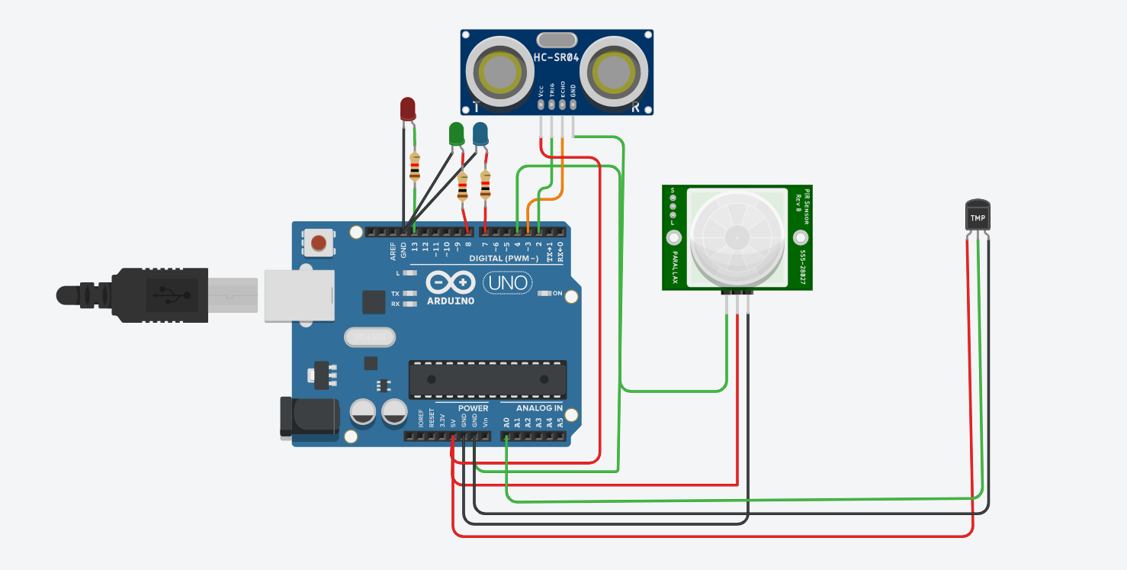

**BY**

**B.SONIYA**

**M.KIRTHIKA**

**T.SINDHUJA**

**S.KARUNYA VARDANA**